Date:

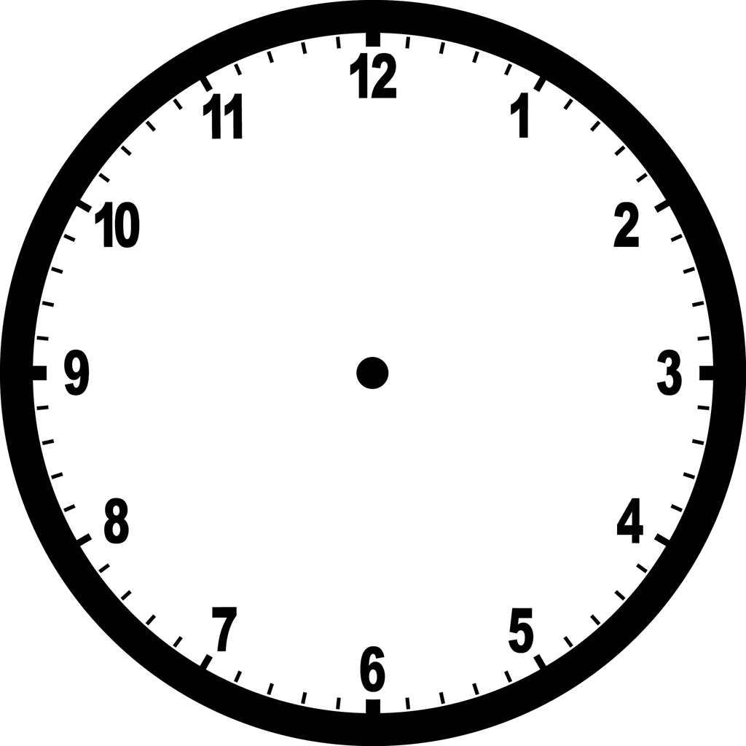
Resources for the day:
Type in this box

The 5-Minute #TeachMeet Plan
… plan and type your way to an inspiring and informal Teacher-Led PD session teachers!
Timing:
Type in this box

Venue / Facilities
Type in this box

Hosts / Tasks
Type in this box

Social Media / Websites / Hashtag
Type in this box

Prizes / Donations / Sponsors
Type in this box

Reminders for the day:

Presenters / Keynote
Arrival / Check-in / Logistics Backchannel/Reflection
Notes to Remember

Type in this box

Type in this box

Type in this box

Adapted by Dr. Helen Teague, helen@4oops.net for ESC Region One. The Attribution: #5MinTeachMeetPlan by Ross Morrison McGill is licensed under a Creative Commons Attribution-NonCommercial- NoDerivs 3.0 Unported License by @TeacherToolkit.

